Cloud Architect, Cloud Network Engineer, Cloud Security Engineer, Cloud Administrator

Networking

**Lab Details**

1. This lab walks you through the steps to add origin EC2 Public IPv4 DNS and S3 bucket endpoint as the origin in CloudFront distribution. And club both of these together in Origin Groups.
2. Duration: **90 minutes**
3. AWS Region: **US East (N. Virginia) us-east-1**

**Introduction**

What is CloudFront?

* Amazon CloudFront is a content delivery network (CDN) offered by AWS.
* CDN provides a globally-distributed network of proxy servers that cache content, i.e., web videos or other bulky media, more locally to consumers, thus improving access speed for downloading the content.
* CloudFront service works on a pay-as-you-go basis.
* CloudFront works with origin servers like S3, EC2 where the content is stored and is pushed out to multiple CloudFront servers as content is requested.
* When CloudFront is enabled, the content is stored on the main S3 server.
* Copies of this content are created on a network of servers around the world called CDN.
* Each server within this network is called an Edge server, which will only have a copy of your content.
* When a request is made to the content, the user is provided from the nearest edge server.
* CloudFront has features similar to dynamic site acceleration, a method used to improve online content delivery.
* CloudFront accelerates the delivery of dynamic content by moving it closer to the user to minimize the internet hops involved in retrieving the content.
* CloudFront's Web distribution supports "**Progressive**" download i.e., data from S3 is cached and then streamed without disruptions.
* Due to that, the user cannot move front or back in the video i.e., the video is processed bit by bit.
* CloudFront's Web distribution support "**Streaming**" allows users to directly watch without any download.
* Due to that, the user can move front or back in the video, the latency is based on the size of the file and the customer's Internet bandwidth.
* This service is beneficial for those developing a website that distributes a lot of content and needs to scale up.
* It helps reduce costs and improve the performance of a website by providing high data transfer speeds and low latency.

**Architecture Diagram**

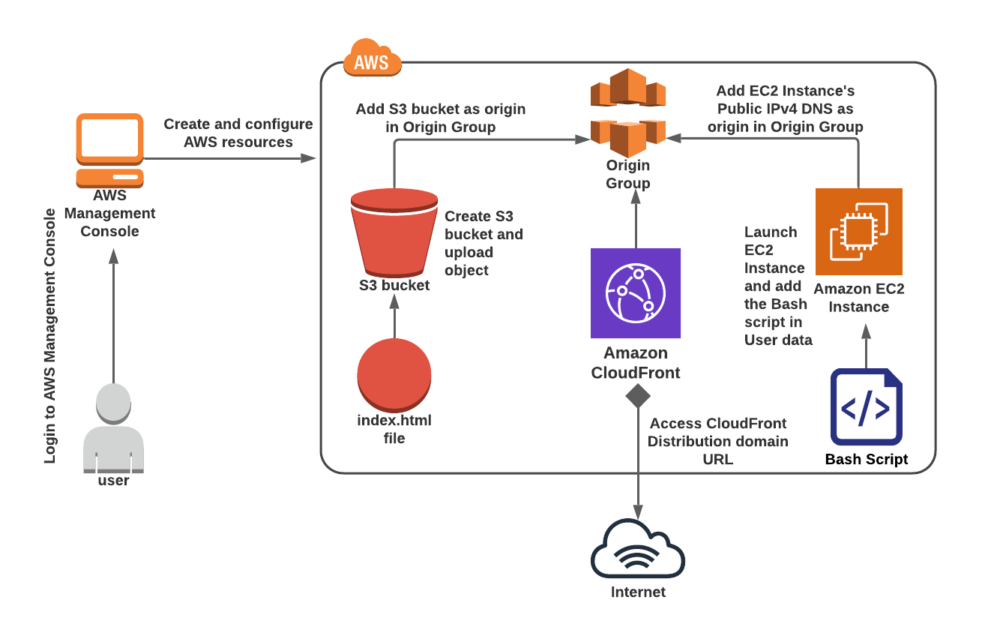

**Task Details**

1. Sign in to the AWS Management Console.
2. Create S3 Bucket
3. Upload a file to an S3 bucket
4. Make the objects publicly accessible
5. Creating CloudFront Distribution
6. Launching an EC2 Instance
7. Add EC2 as the Origin and create Origin Group
8. Test the Origin group
9. Validation of the lab.
10. Deleting AWS Resources.

**Launching Lab Environment**

1. To launch the lab environment, Click on the  button.
2. Please wait until the cloud environment is provisioned. It will take less than a minute to provision.
3. Once the Lab is started, you will be provided with **IAM user name**, **Password**, **Access** **Key**, and **Secret** **Access** **Key**.

**Note** : You can only start one lab at any given time